# ONLINE SHOPPING MANAGEMENT USING JDBC

MINOR PROJECT REPORT

By

**TAHSHEEN FATIMA (RA2211056010031)**

**TANISHA DHOOT(RA2211056010009)**

**RITI MATANGI (RA2211056010035)**

**DHIVYA(RA2211056010021)**

Under the guidance of   
**Dr. V. Vijayalakshmi***In partial fulfilment for the Course*

of

**21CSC206P – ADVANCED OBJECT ORIENTED AND PROGRAMMING**

in DSBS Department



**FACULTY OF ENGINEERING AND TECHNOLOGY**

**SCHOOL OF COMPUTING**

**SRM INSTITUTE OF SCIENCE AND TECHNOLOGY**

**KATTANKULATHUR**

**NOVEMBER 2023**

**SRM INSTITUTE OF SCIENCE AND TECHNOLOGY**

**(Under Section 3 of UGC Act, 1956)**

**BONAFIDE CERTIFICATE**

Certified that this minor project report for the course **21CSC206P** **ADVANCED OBJECT ORIENTED AND PROGRAMMING** entitled in "**Online Shopping Management System Using**" is the bonafide work of  **Tahsheen Fatima (RA2211056010031), Tanisha Dhoot (RA2211056010009), Riti Matangi (RA2211056010035) and Dhivya (RA2211056010021)** who carried out the work under my supervision.

# SIGNATURE

Dr. V. Vijayalakshmi

Assistant Professor

Department of DSBS

SRM Institute of Science and Technology

Kattankulathur

# ABSTRACT

The “Online Shopping Management System Using JDBC” stands as a culmination of our dedicated efforts to create a cutting-edge e-commerce platform, seamlessly integrating the robust capabilities of Java Database Connectivity (JDBC). At the heart of this project is a resilient user authentication system, ensuring secure logins and precise role-based access controls. Leveraging the dynamic functionalities of JDBC, our system excels in managing a diverse product catalog with ease, allowing for real-time additions, modifications, and deletions. The responsive shopping cart system, powered by JDBC, guarantees a user-friendly and streamlined checkout experience. Real-time order processing and inventory management functionalities, intricately woven with JDBC, reflect our commitment to accuracy and efficiency. The secure integration of payment gateways, backed by JDBC, underscores our dedication to compliance and user data protection. With advanced search features, responsive design principles, and scalable operations facilitated by JDBC, this project not only meets current industry demands but also lays a solid foundation for continuous innovation and enhancements in the realm of online retail.

# ACKNOWLEDGEMENT

We express our heartfelt thanks to our honorable **Vice Chancellor Dr. C. Muthamizhchelvan**, for being the beacon in all our endeavors.

We would like to express my warmth of gratitude to our **Registrar Dr. S. Ponnusamy,** for his encouragement.

We express our profound gratitude to our **Dean (College of Engineering and Technology) Dr. T. V. Gopal,** for bringing out novelty in all executions.

We would like to express my heartfelt thanks to Chairperson, School of Computing **Dr. Revathi Venkataraman,** for imparting confidence to complete my course project

We wish to express my sincere thanks to **Course Audit Professors Dr. Vadivu. G, Professor, Department of Data Science and Business Systems and Dr. Sasikala. E Professor, Department of Data Science and Business Systems** and **Course Coordinators** for their constant encouragement and support.

We are highly thankful to my Course project Faculty **Dr. V. Vijaylakshmi, Assistant Professor, DSBS,** for his/herassistance, timely suggestion and guidance throughout the duration of this course project.

We extend my gratitude to our **HoD Dr. M Lakshmi, Professor, Department of Data Science and Business Systems** and my Departmental colleagues for their Support.

Finally, we thank our parents and friends near and dear ones who directly and indirectly contributed to the successful completion of our project. Above all, I thank the almighty for showering his blessings on me to complete my Course project.

**TABLE OF CONTENTS**

|  |  |  |
| --- | --- | --- |
| **CHAPTER NO** | **CONTENTS** | **PAGE NO** |
| **1** | **INTRODUCTION** |  |
|  | 1.1 Motivation |  |
|  | 1.2 Objective |  |
|  | 1.3 Problem Statement |  |
|  | 1.4 Challenges |  |
| **2** | **LITERATURE SURVEY** |  |
| **3** | **REQUIREMENT ANALYSIS** |  |
| **4** | **ARCHITECTURE & DESIGN** |  |
| **5** | **IMPLEMENTATION** |  |
| **6** | **EXPERIMENT RESULTS & ANALYSIS** |  |
| **7** | **CONCLUSION** |  |
| **8** | **REFERENCES** |  |

**1.** **INTRODUCTION**

In the ever-evolving landscape of e-commerce, the motivation behind the development of the Online Shopping Management System lies in addressing the growing demand for streamlined and user-centric platforms. The surge in online shopping underscores the need for a comprehensive system that not only facilitates efficient product management but also ensures a seamless experience for users navigating through an extensive array of offerings. The aim is to create a versatile solution that caters to the diverse needs of both administrators seeking to manage their product catalogs effectively and customers looking for a hassle-free shopping experience.

The primary objective of this project is to design and implement a robust online Shopping Management System using JDBC, aiming to provide a feature-rich and intuitive platform for users. The system’s objectives encompass the seamless addition, updating, and deletion of products, efficient order processing, and a user-friendly interface. Through the integration of Java Database Connectivity (JDBC), the project seeks to establish a secure and efficient connection between the application server and the database, ensuring reliable data management and retrieval. The end goal is to contribute to the digital retail space by offering a scalable, responsive, and user-centric online shopping solution.

The project addresses the challenges associated with traditional retail management systems and aims to overcome hurdles in effectively managing product information, user interactions, and order processing. In many conventional setups, the absence of a centralized and user-friendly online platform leads to inefficiencies, making it challenging for administrators to maintain up-to-date product catalogs and for customers to navigate through diverse offerings seamlessly. This project seeks to bridge these gaps, providing a solution that simplifies the complexities of online retail management and enhances the overall user experience.

**2.LITERATURE SURVEY**

[1] Tomcat was adopted to be the JSP engine and this thesis designs an online health consulting and shopping center that can provide users personal dietary assessment, nutritional news, professional knowledge of nutrition, special diets for patients, the posting of questions and shopping for nutritional supply products. On the other hand, the project connects to a Microsoft Access database using a type 1 JDBC-ODBC Bridge, plus ODBC driver. In this way, staff can easily manage different kind of information in the database of this health center. In short, JSP is more convenient to write by using conventional HTML writing tools and easier to modify because only the dynamic parts need to be changed when updating a web page. Furthermore, JSP with Java is more flexible because they are platform independent.

[2] J2EE model and technology, and the concept and structure of MVC pattern, are introduced in this paper. Based on the four-tier J2EE architecture and the MVC pattern, a technology roadmap of the e-commerce system architecture is planned out: JSP plus Servlet plus Session Bean plus CMP plus database, which makes up the shortcomings of unclear business logic among tiers in J2EE, simplifies the development process, and can develop a stronger e-commerce system with scalability and maintainability. Finally, a realistic system is put forward with the roadmap, which further demonstrates our conclusion and research.

[3] Large web or e-commerce sites are frequently hosted on clusters. Successful open-source tools exist for clustering the front tiers of such sites (web servers and application servers). No comparable success has been achieved for scaling the backend databases. An expensive SMP machine is required if the database tier becomes the bottleneck. The few tools that exist for clustering databases are often database-specific and/or proprietary. Clustered JDBC (C-JDBC) addresses this problem. It is a freely available, open-source, flexible and efficient

middleware for database clustering. C-JDBC presents a single virtual database to the application through the JDBC interface. It does not require any modification to JDBC-based applications. It furthermore works with any database engine that provides a JDBC driver, without modification to the database engine. The flexible architecture of C-JDBC supports large and complex database cluster architectures offering various performance, fault tolerance and availability tradeoffs. We present the design and the implementation of C-JDBC, as well as some uses of the system in various scenarios. Finally, performance measurements using a clustered implementation of the TPC-W benchmark show the efficiency and scalability of C-JDBC.

[4] Web-Services can be referred as a family of technologies that standardized the communication of applications through world wide web in a cost-effective manner. Few of the major software vendors like IBM, Microsoft, Oracle, SAP are all embracing the web service standards into the newer versions of their applications which are web services enabled. All the constrains like cost, time, space for discovering, and ebusiness transactions can be solved easily by using webservices. With the introduction of these Web services design of the business application to provide service, integrating with other business entities, and conducting business transactions completely changed the working of a business organization. These web-services became a viable component in distributed E-Commerce platforms. In determining server response time, high speed communication systems along with computing capacity and network latency have become important. In web technologies a new model of architecture for distributed E-Commerce applications has been proposed which aims at integration and inter-operation between different platforms. In this paper we have proposed a model for developing an E-Commerce application using the Spring framework which helps in easy integration with other frameworks and solves most difficulties in an enterprise application development.

**3. REQUIREMENTS**

* 1. **Requirement Analysis**
* User Authentication: Implement a secure user authentication system for login and access control.
* Product Management: Develop features for adding, updating, and deleting products in the online catalog.
* Shopping Cart Functionality: Create a responsive shopping cart system for users to manage selected items.
* Order Processing: Implement a secure order processing system with real-time updates and confirmation.
* Payment Integration: Integrate secure payment gateways for seamless and compliant transactions.
* Responsive Design: Ensure a user-friendly and responsive design across various devices.
  1. **Hardware Requirement**

From the given scenario, we draw the following requirements:

1. Application Server:

- Processor: Dual-core 2.0 GHz or higher

- RAM: 8 GB or more

- Storage: 100 GB SSD or higher

2. Database Server:

- Processor: Quad-core 2.5 GHz or higher

- RAM: 16 GB or more

- Storage: 200 GB SSD or higher

3. Client Devices:

- Processor: Dual-core 1.5 GHz or higher

- RAM: 4 GB or more

- Storage: 128 GB SSD or higher

4. Network Equipment:

- High-speed internet connection

- Router with Gigabit Ethernet ports

5. Monitoring Server:

- Processor: Quad-core 2.0 GHz or higher

- RAM: 8 GB or more

- Storage: 100 GB SSD or higher

**4.ARCHITECTURE AND DESIGN**

* 1. **Network Architecture**

The network architecture is as follows:

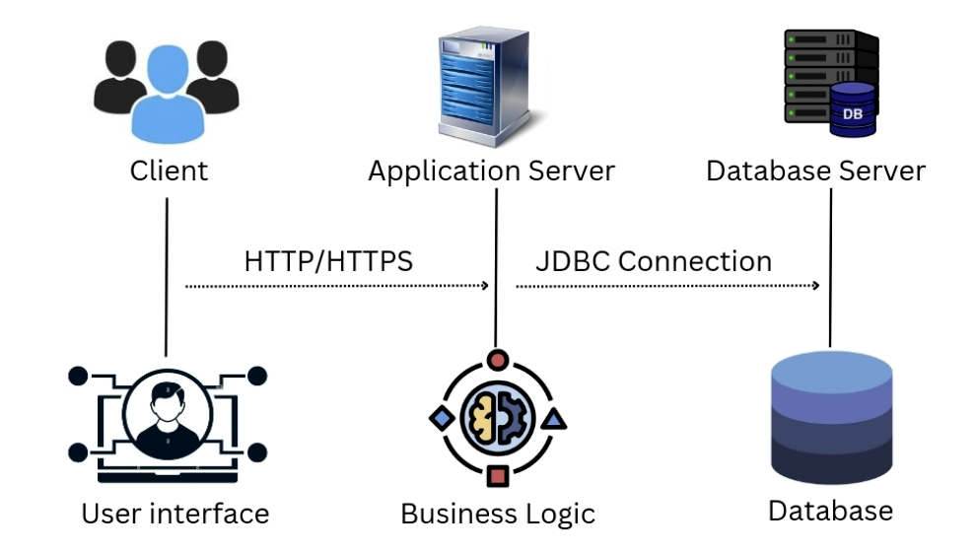

The architecture consists of three major networks:

1. Client: The client serves as the user interface, enabling interactions with the Online Shopping Management System through web browsers or mobile applications.
2. Application Server: The application server hosts the system’s business logic, processing user requests, and facilitating communication between the client and the database server.
3. Database Server : The database server stores and manages product, user, and order data, ensuring data integrity and security for the Online Shopping Management System.
4. User interface: The user interface is the visual platform, either web or mobile, through which users interact with the system, initiating requests and navigating through the available functionalities.
5. Business Logic: Business logic resides on the application server, executing operations like product management, order processing, and user authentication, ensuring the core functionality of the Online Shopping Management System.
6. Database: The database stores structured data, including products, user details, and orders, serving as the persistent storage for the Online Shopping Management System and supporting efficient data retrieval and updates.

**5. IMPLEMENTATION**

* 1. **Database Setup**

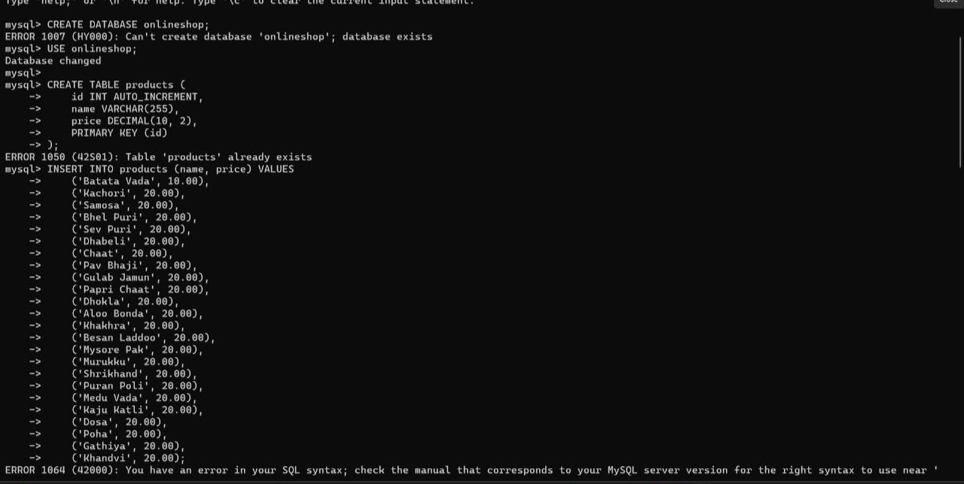

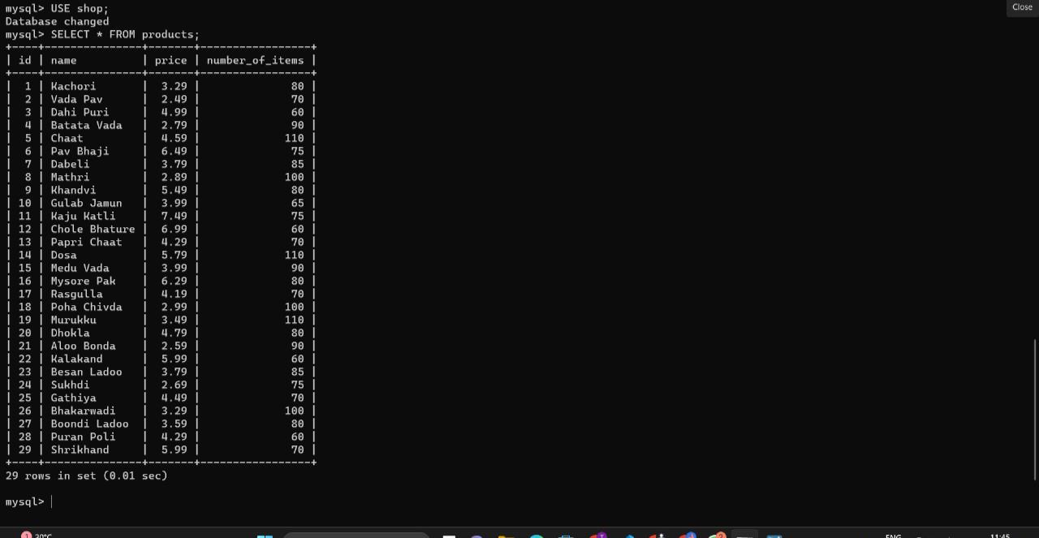

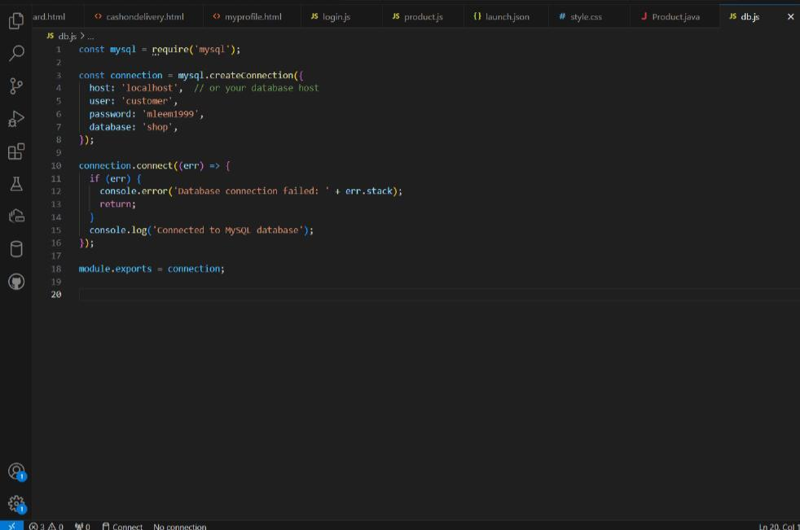

* 1. **User Authentication**

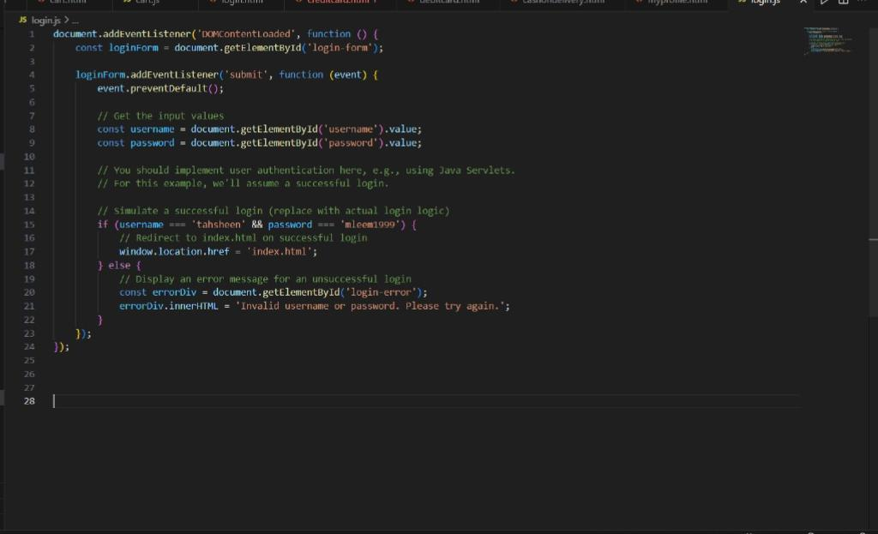

* 1. **Product And Inventory Management:**

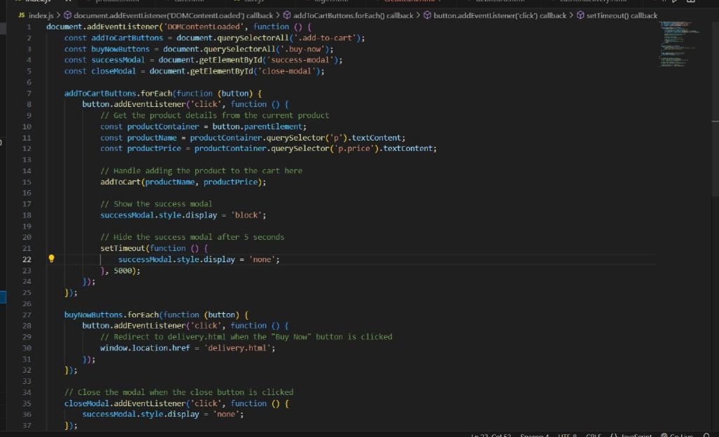

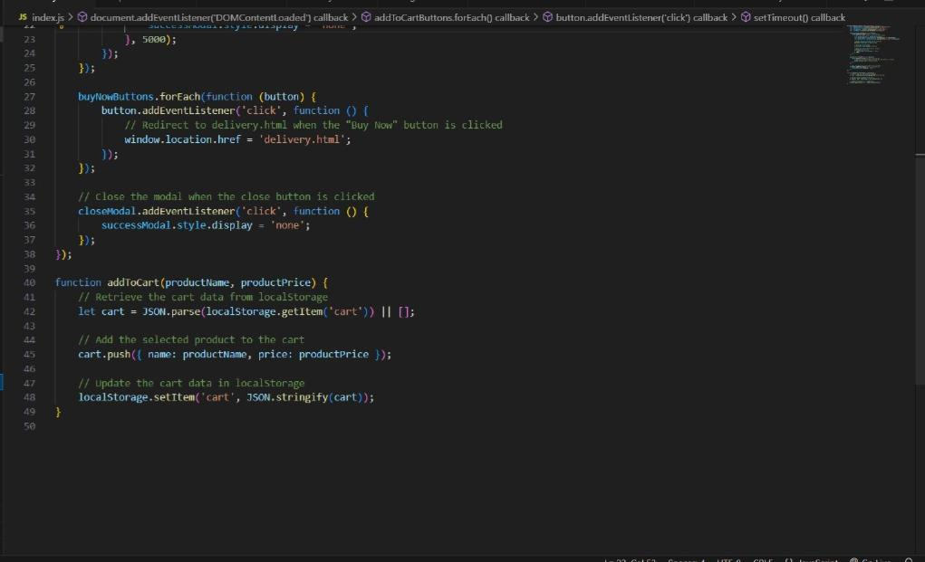

* 1. **Shopping cart and Order Processing:**

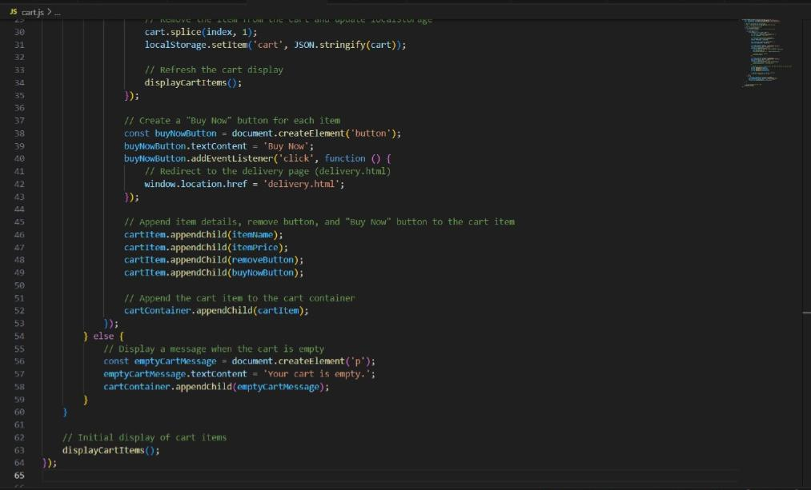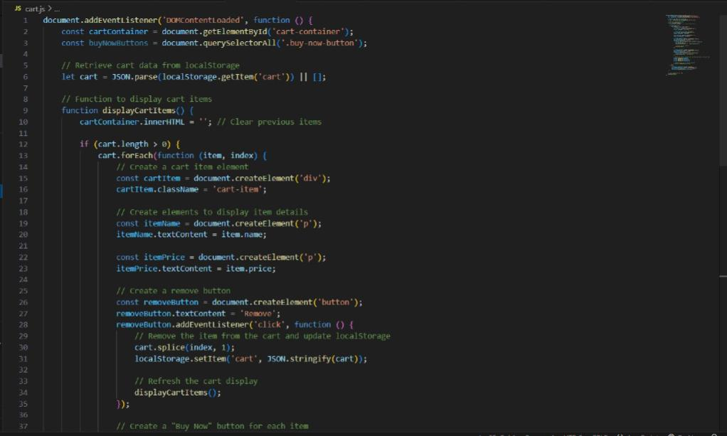

* 1. **Payment Integration:**

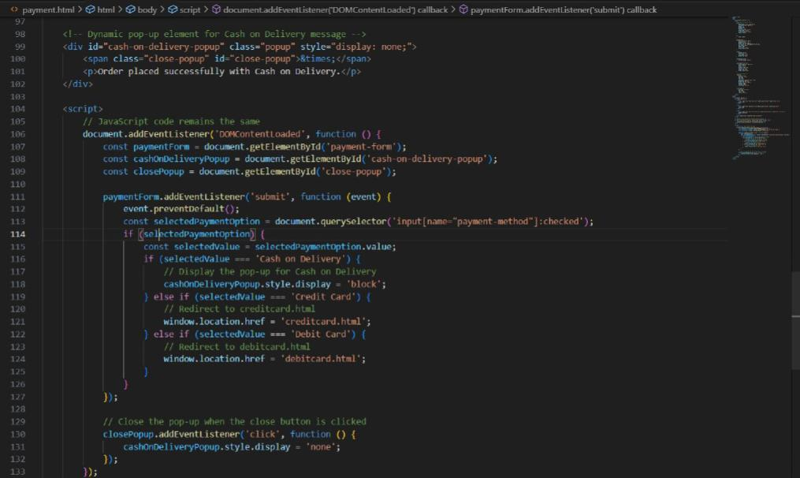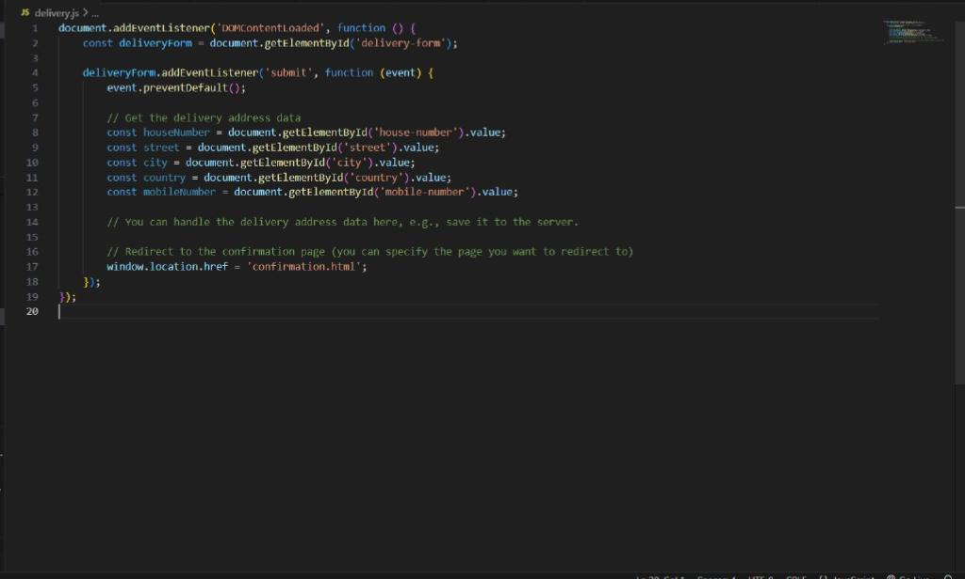

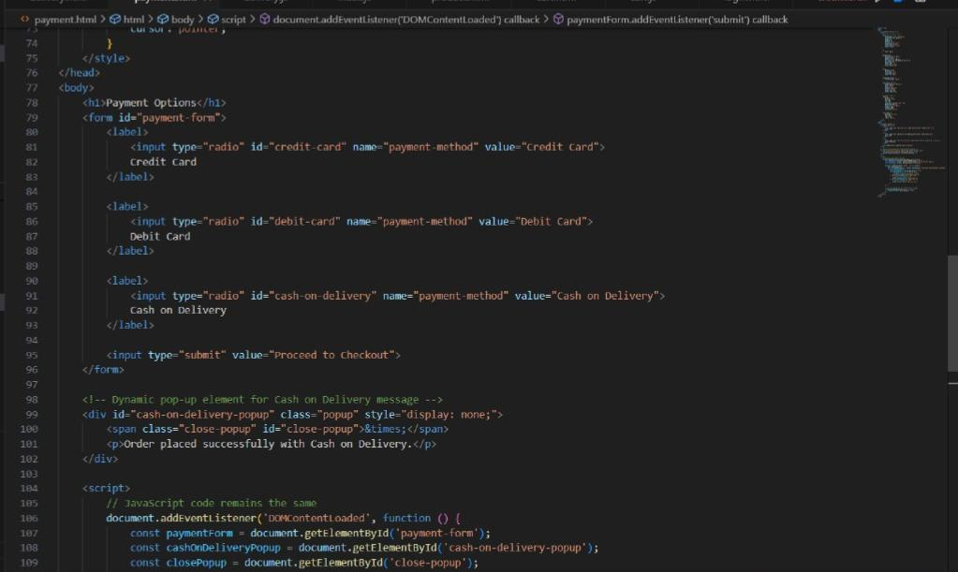

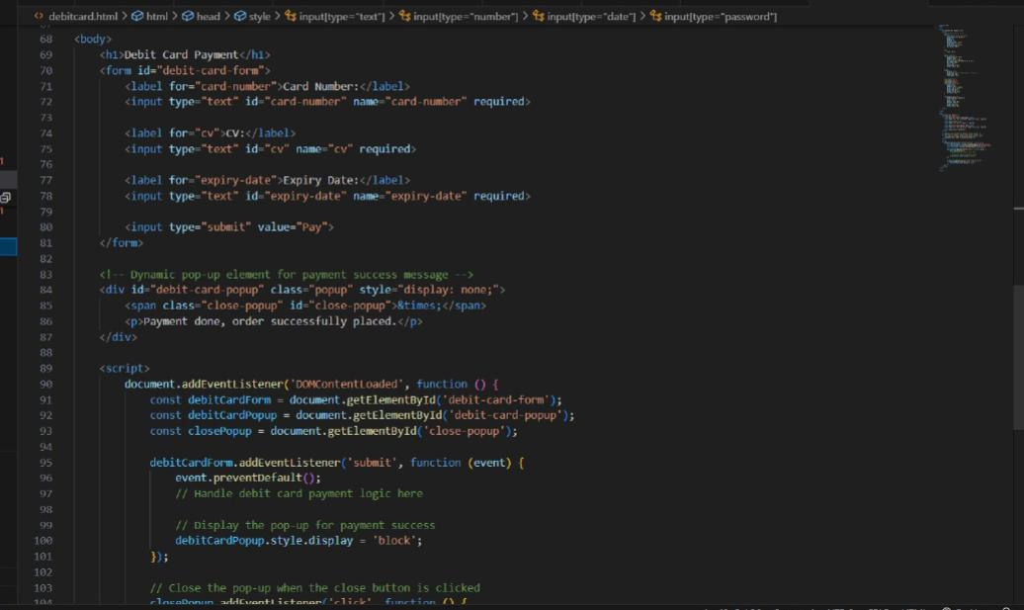

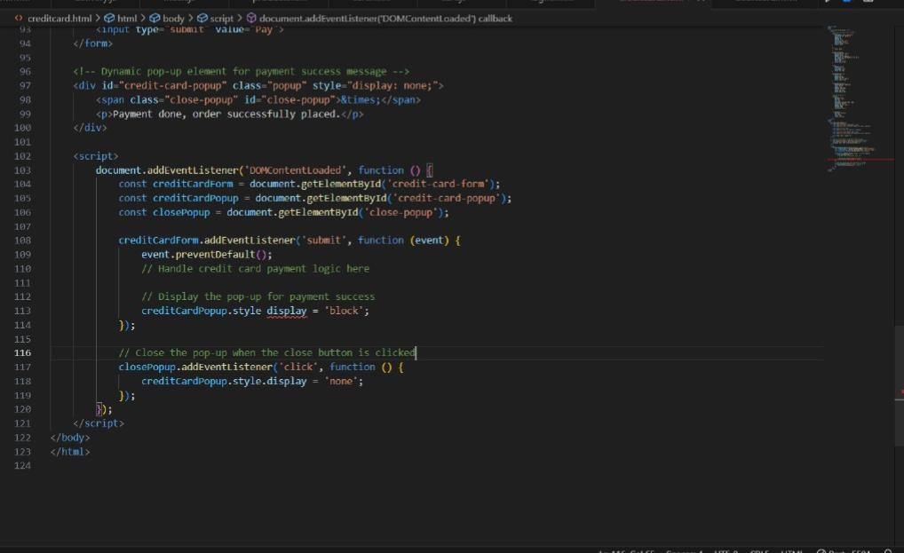

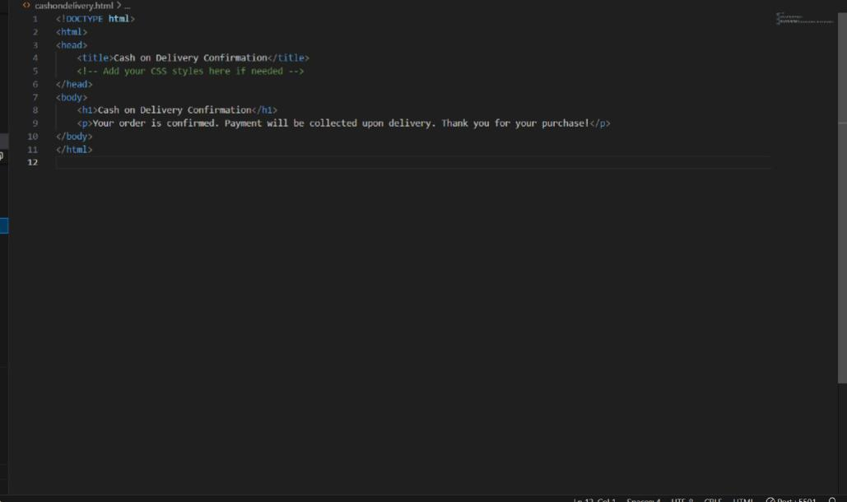

**6.RESULTS AND DISCUSSION**

* 1. **Login Page**

User authentication is performed.

If login is successful, user is redirected to main page(index.html).

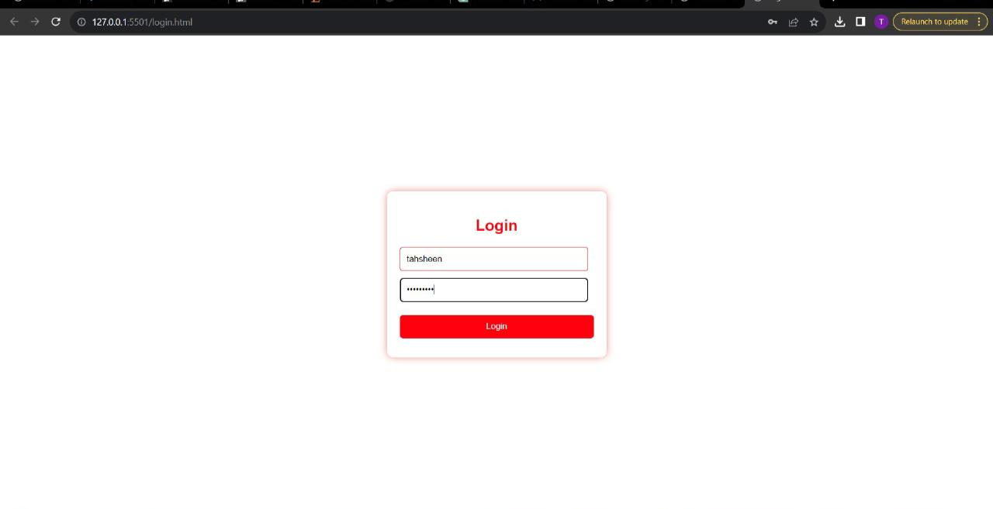

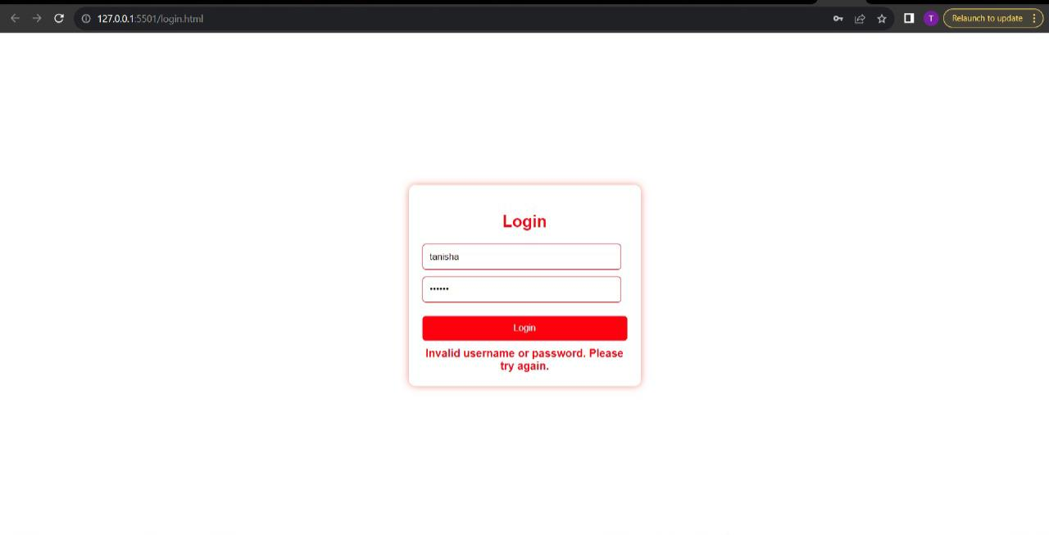Else, it gives an error message of invalid username or password.

* 1. **Main Page(index.html)**

Main Page displays all the products along with the options to view cart and your profile.

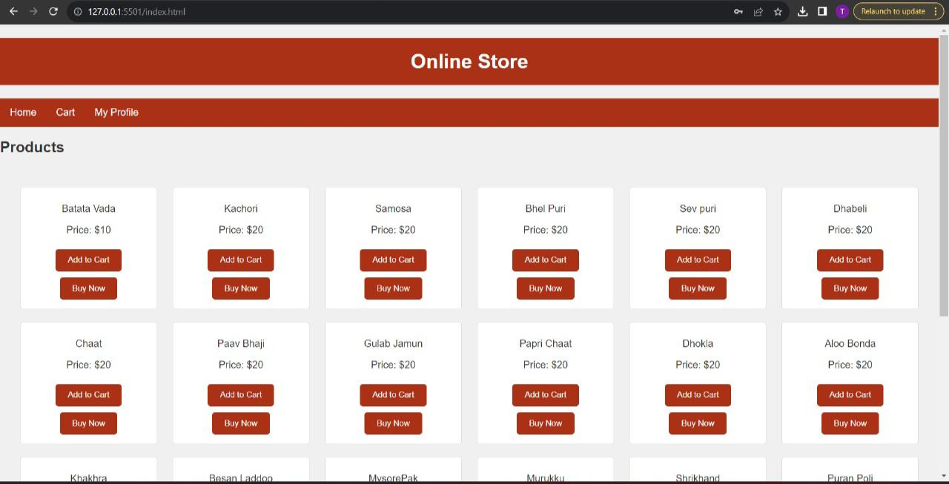

* 1. **Add to cart**

Add to cart function saves the items in the cart and can be viewed from the cart option in home page**.**

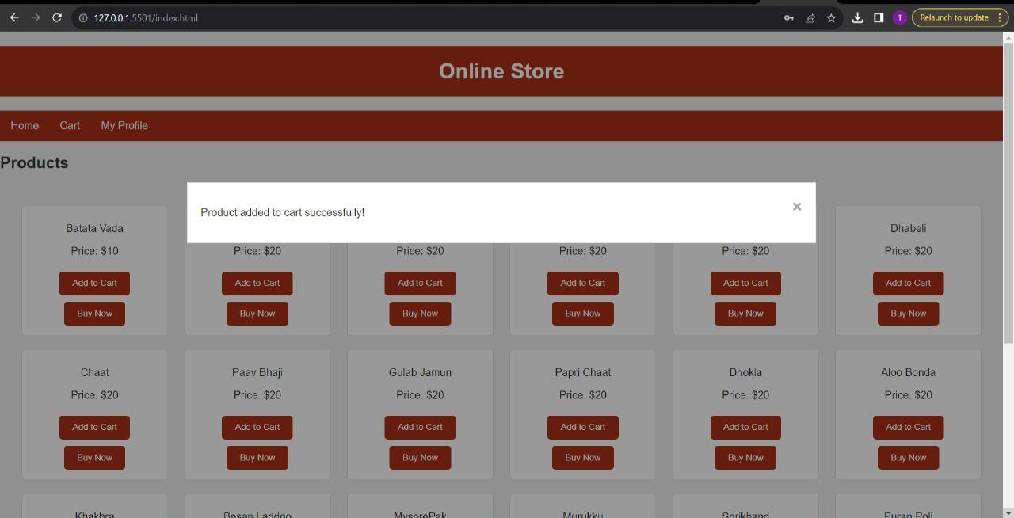

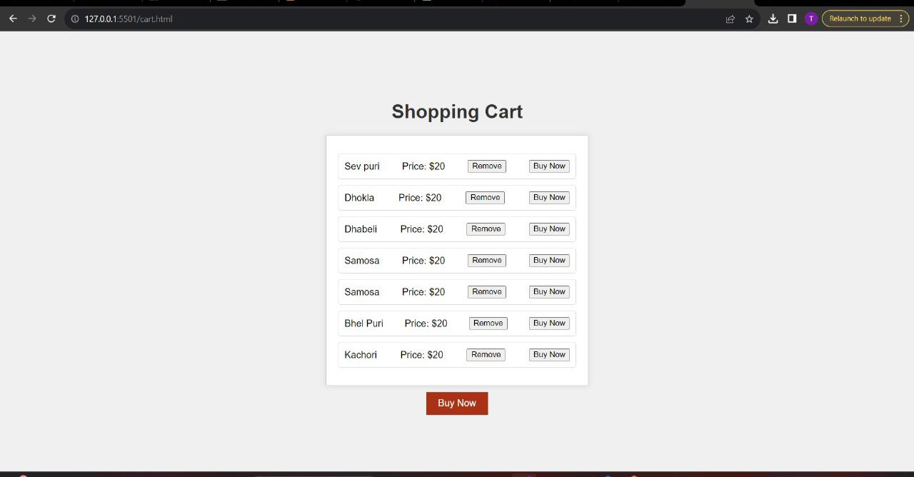

* 1. **View my profile**

**You can also view the profile using the profile option in home page.**

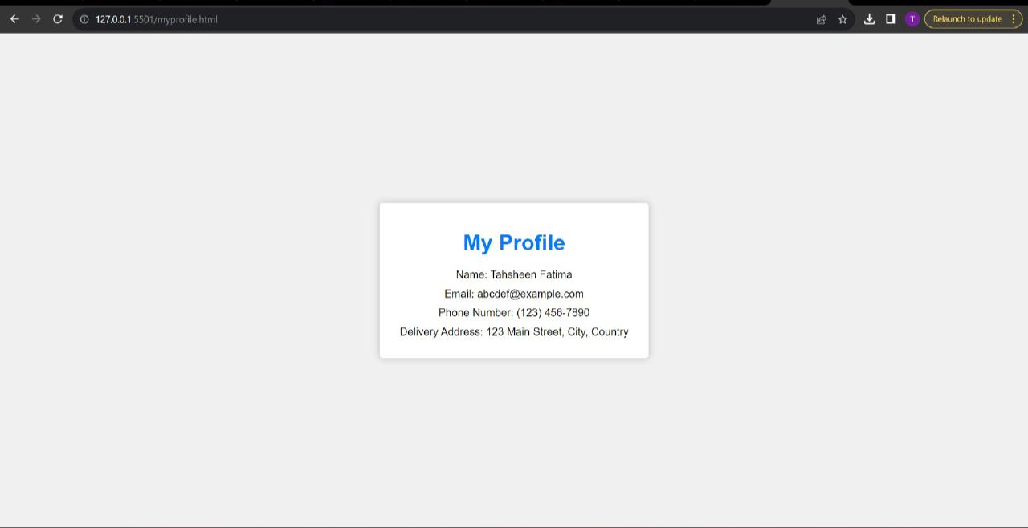

* 1. **Buy now**

You get redirected to delivery page after clicking on buy now button.

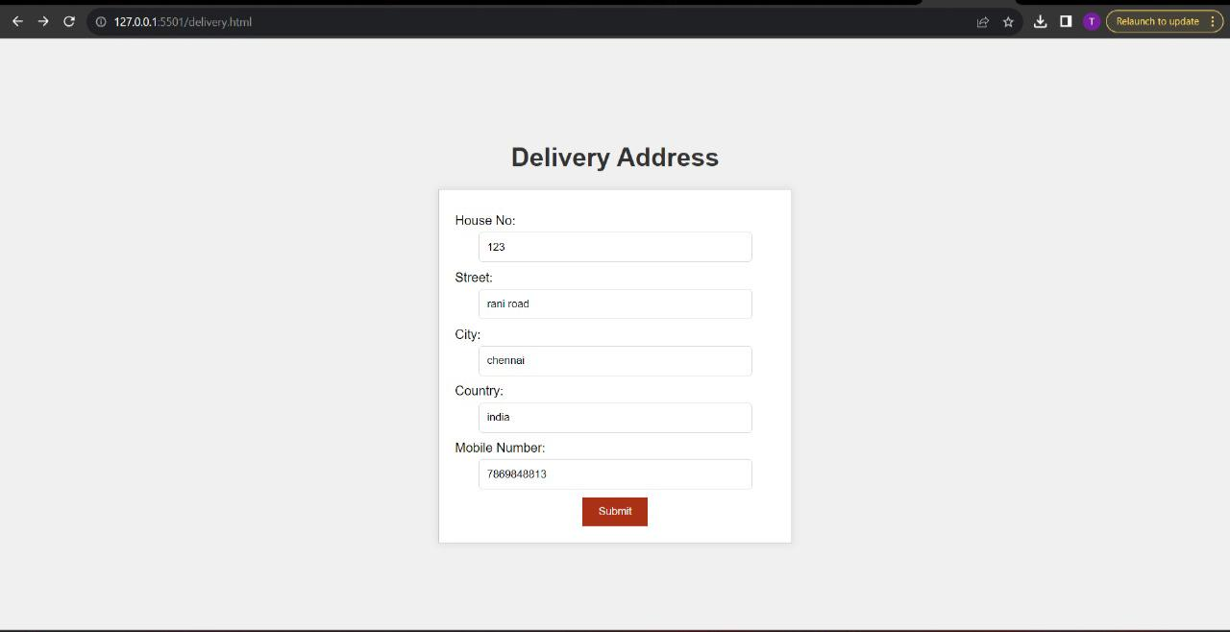

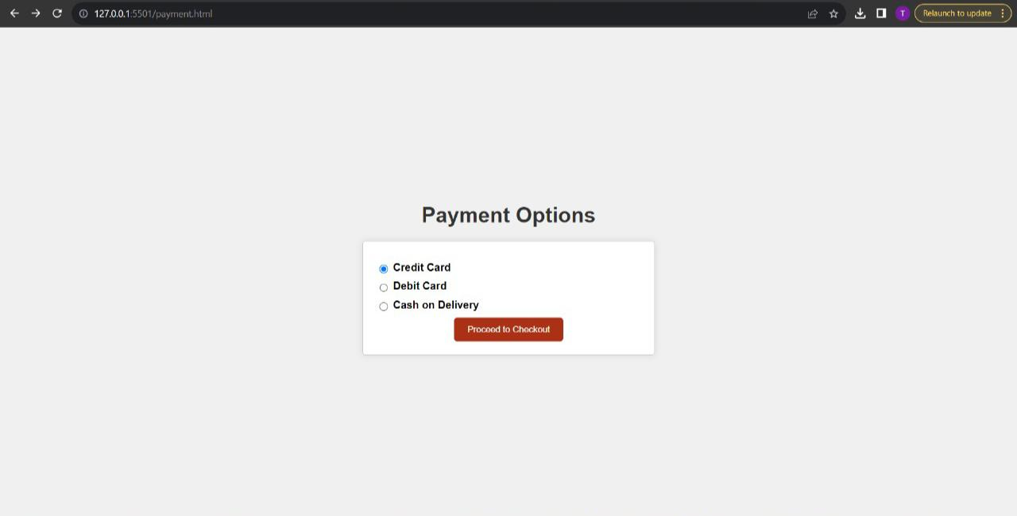After filling delivery details, you get redirected to payment page.

You get redirected to credit card form if you select credit card option.

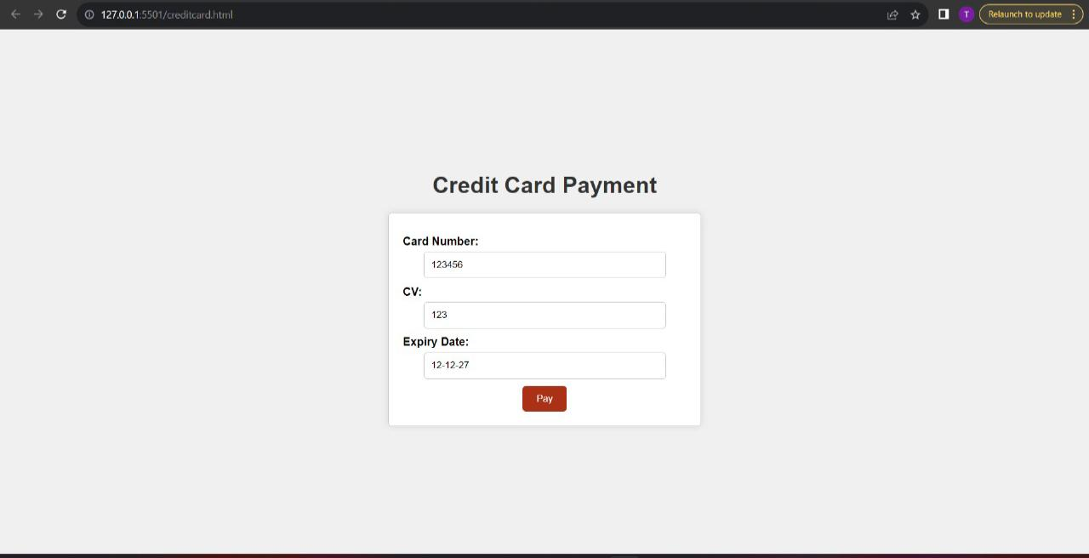

If you submit credit card details, you get pop up message of payment successful.

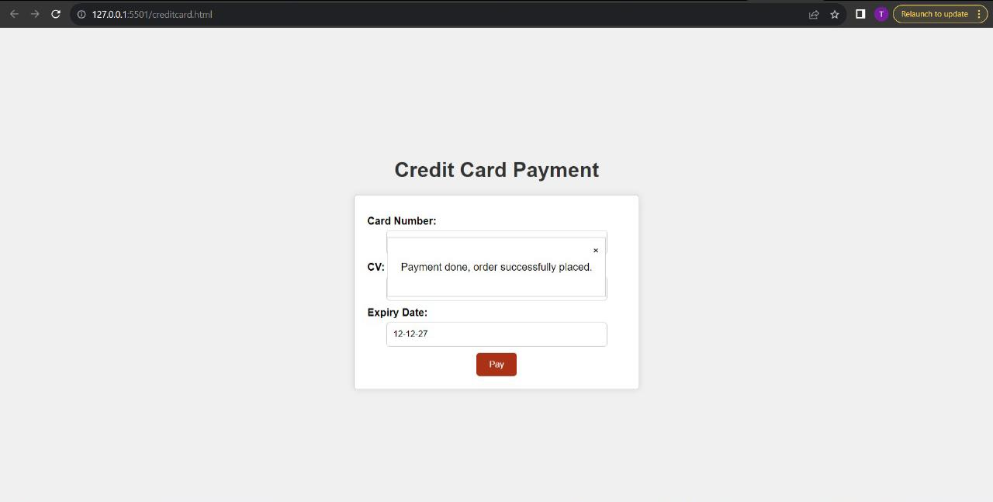

Similarly, we can also select debit card option.

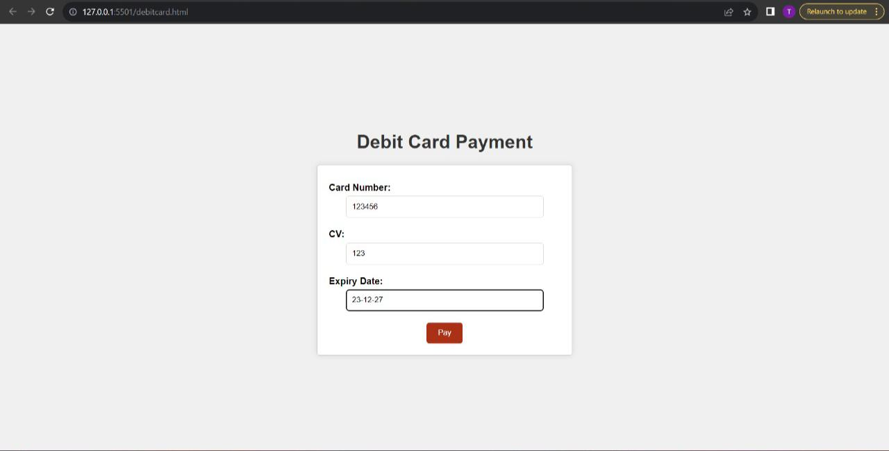

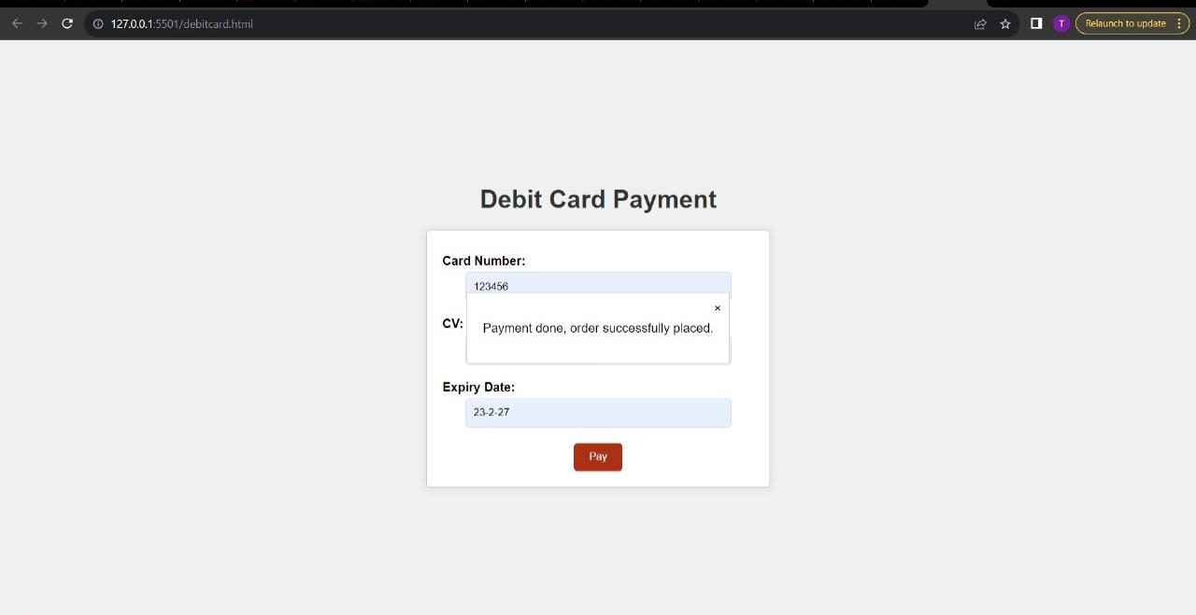

You can also select cash on delivery option.

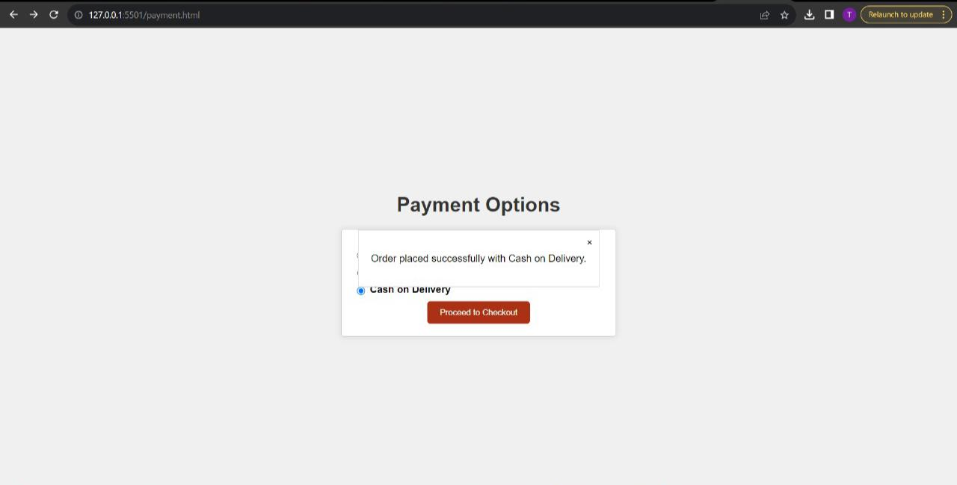

1. **CONCLUSION**

In conclusion, the development of the Online Shopping Management System using JDBC has been a significant undertaking aimed at creating an efficient and user-friendly platform for managing product catalogs, user interactions, and order processing. Through the implementation of a robust architecture, incorporating elements such as an application server, database server, and secure communication protocols, the system aims to provide a seamless experience for both administrators and customers. The integration of JDBC ensures reliable and optimized data management, enabling functionalities like adding, updating, and deleting products, as well as placing and viewing orders. The project underscores the importance of meticulous design, attention to security, and scalability considerations in creating a well-rounded online shopping solution. As technology continually evolves, this project serves as a foundation for further enhancements and adaptations to meet the dynamic needs of e-commerce environments.

**8. REFERENCES**

[1] Architecture of e-commerce systems based on J2EE and MVC pattern

Yanfang Wang, Chunyan Guo, Lei Song

[2] AN ONLINE HEALTH CONSULTING AND SHOPPING CENTER IMPLEMENTED ВΥ JAVASERVER PAGES

HsieniMin Yeh

[3] C-JDBC: Flexible database clustering middleware, Emmanuel Cecchet, Marguerite Julie, Willy Zwaenepoe

[4] E-Commerce applications using Web-Services

Sailesh Tirumala, Yatesh Laxman Kumar Gumma, Seethamraju Phaneendra, Jinan Fiaidhi